

**HOTEL RESERVATION AND MANAGEMENT SYSTEM.**

**BY: TIMOTHY ROHA**

**REG NO: COM/044/18**

**RESEARCH PROJECT SUBMITTED TO THE SCHOOL OF SCIENCE AND DEPARTMENT OF MATHEMATICS AND COMPUTER SCIENCE IN PARTIAL OF THE REQUIREMENTS OF BACHELOR OF SCIENCE IN COMPUTER SCIENCE AT UNIVERSITY OF ELDORET.**

**APRIL 2022**

# 

# DECLARATION

I hereby declare that this research proposal is my original work and has never been submitted for award of degree certificate in any university.

**TIMOTHY ROHA COM/044/18**

**SIGNATURE……………………………………. DATE…………………………..**

This research document has been submitted with my approval as the university supervisor.

**SIGNATURE…………………………………….. DATE………………………**

**DR. LILIE SIELE**

**LECTURER**

**DEPARTEMENT OF MATHEMATICS AND COMPUTER SCINECE**

**UNIVERSITY OF ELDORET**

# ACKNOWLEDGMENT

My sincere and special thanks to all my lectures that I have been sitting and listening to them. The have really impacted knowledge and vital guidance in ensuring that I conduct a successful study.

Beside my lectures, I would like to thank all my classmates for having provided the necessary support in ensuring that I am on the right track concerning my academic life.

I also appreciate the whole university fraternity for having contributed to my success in this project for having provide a very conducive environment for my study while at the university environs and even outside university.

**TABLE OF CONTENT**

DECLARATION 2

ACKNOWLEDGMENT 3

ABSTRACT 5

CHAPTER ONE: INTRODUCTION 6

1.1Background information 6

1.2 PROBLEM STATEMENT 7

1.3 OBJECTIVES OF THE STUDY 8

1.4 Scope and boundary 9

1.5 JUSTIFICATION 9

CHAPTER TWO: LITERATURE REVIEW 10

2.1 Overview and analysis of related work 10

2.2 Elements of a system 12

2.3 Benefits of hotel website system 13

2.4 Summary 13

CHAPTER THREE: METHODOLOGY 14

3.1 System development methodology 14

3.2 Requirement analysis 15

3.3 System design 16

3.4 System analysis and design tools 17

3.5 Software implementation tools 18

3.5.1 Hardware requirements 18

3.5.2 Software requirements 18

3.6 System testing and validation 18

3.6.1 Functional testing 19

3.6.2 Non-functional testing 20

CHAPTER FOUR: SYSTEM ANALYSIS AND DESIGN 21

4.1 System analysis tools 21

4.1.1 Activity diagram 21

4.1.2 Use case diagrams 23

4.1.3 Data Flow Diagram (DFD) 24

4.1.4 Entity relational diagram 25

CHAPTER FIVE: SYSTEM IMPLEMENTATION, TESTING AND VALIDATION 26

5.1 Hardware Requirements 26

**5.2** Application login window 27

5.3 Home page 28

5.4 Create account menu 29

5.5 Admin window 29

5.6 Administrators’ activities 30

5.7 Retrieval of stored data 30

CHAPATER SIX: SUMMARY, CONCLUSION AND RECOMMENDATION. 31

6.1 Summary 31

6.2 Conclusion 32

6.3 Limitations 32

6.4 Recommendation 32

6.4.1 Suggestion for further work 32

References 33

### ABSTRACT

This project examines the aspect of the hospitality industry which is Hotel management. In the 21st century the use of the internet, computer and other electronic devices have made handling different jobs and aspects of management very easy. This project is the design and implementation of an electric hotel management system that provides a user friendly interface with which the user can easily with the little or elementary knowledge of operating computers.

This project is designed to create a platform that allows the user and administrator to keep track of each and every transaction like room reservation, room addition and other day to day activity involved in the running and management of a hotel. The implementation id based on the requirements for hotel management system. Hotel reservation and management system will provide a facility for booking hotels, in-houses, and other accommodation for the customers. There will be no need for customers to keep visiting the hotel for bookings and hotel reservations processes to be done instead they will be able to do it online. To the benefit of the owners of the hotel also they will be able to manage the customers booking easily and also keep the customer data more safely and data can be retrieved upon need.

Customers are also going to receive the necessary feedback on time since the attendants will keep track of their bookings.

The system is developed to be used by hotel staff and for better management of the hotel process. It is developed to replace the manual system that mostly used. There have been many problems during use of the manual system, like data redundancy, loss, or damage.

The scope that exist in this system are booking online room, rent room, make payments using system, generate report for the hotel, make a checklist and make an ordering using system that is provide in the hotel. Data used in this was collected using observation, reviewing of the existing documents and interview methods. Interviews were conducted using interview guides.

The project was designed with the use of Microsoft Visual studio Code which is an integrated development environment made by Microsoft. The project was implemented using MYSQL database and JavaScript programming language. This project can be very useful when implemented by speeding up the process of determining the status of client’s requests submitted hourly, daily, weekly, monthly or even yearly.

# 

## 

# CHAPTER ONE: INTRODUCTION

**1.1 Background information**

Kenya as a country is growing tourist attraction in East African and in the world today.

According to capital FM (Nairobi) tourism earnings grew up by 65.4 % last year to Sh146.51bn compared to Sh88.56bn in 2020. It is evident that the sector is recovering from the effects of Covid 19. According to the 2021 tourism sector statistics, the USA was the top source market for tourist with 136,981 arrivals. Uganda come in second with 80,067 arrivals followed by Tanzania and United Kingdom with 74,051 and 51,264 arrivals respectively.

The data alone attests that the tourism sector in the country is broadening thus a great need for making hotel reservation system website. The rapid development and commercialization of information and communication technologies (ICT) for the travel and tourism industry has prompted hotels and other enterprises in this sector to increasingly adopt these technologies.

The ICT based product and processes help the hotels to enhance the operating efficiency, improved the service experience as well as provide a means to access the markets on a global basis.

More than 500 hotels in the country receive international tourist. In 2019 it is approximated that more than 2 million people visited the country some being tourist, investors and even students. This number declined in 2020 as result of Covid 19. The result a dire effects on the tourism sector and hospitality. Like other nations worldwide Kenya implemented measure to contain he spread of the virus such as lockdown and flight restriction.

Manual management and organizational methods such as the traditional pen and paper approach are still utilized in a large number of hospitality settings around the world. The reason is quite simple, they require little investments. So little in fact, the costly trade-offs that a company such methods appear insignificant in the short run. But humans make mistakes and there is no way to get around that, unless of course we minimize said human involvement wherever we can.

## 1.2 PROBLEM STATEMENT

The phase of the system analysis process deals with problems that are affecting the current manual system. The problems are those that are affecting the hotel in its daily routine work. As the growing trend in most business info tech world of computers, need of accuracy, perfectness, speed, and high memory data storage is a must. Each and every problem must be solved with least amount of time and energy.

The problems faced by the existing systems and hope to be solved by the hotel management system are described below:

* Difficulty in the maintenance of records.
* Time consuming.
* Editing of data becomes a tedious job.
* No security of data.
* Lack of efficiency.
* Data redundancy.
* Data inconsistency.

**Difficulty in maintenance of records**: It is very difficult to maintain data record in the system as all the records are entered in the register or the perspective record books. There are chances of the records of the record books or files in which all the data stored may be torn or wearied out or some other damages or files may even be misplaced.

**Time consuming:** it is very time consuming and difficult to write each and every entry and exit of customers into the hotel in register.

**Editing data manually**: manually written data cannot be changed or edited once written. If there is a mistake and the administration tried to cancel it out and write it again this would make the entire register very dirty and disorganized. If data is entered incorrectly the entire system gets incorrect while editing wrongly entered data cannot easily solve errors.

**Data insecurity:** as the data stored in files of registers, it is not a secure place. As the storage media here are files and books or registers, there are chances of getting this storage media lost, torn, or it may go in the hand of the wrong person which can destroy the database or it can also be destroyed accidentally.

**High data redundancy:** as mentioned in the current system. Due to maintenance of so many registers there is high redundancy of data i.e. some data is recorded repeatedly.

**Data inconsistency:** here as mention earlier, the information is written in more than one place that creates the problem, where there is a change or deletion in the recorded data.

## 1.3 OBJECTIVES OF THE STUDY

**Main objectives**

The main objectives of this project was to develop a computerized tool that shall help in tracking clients request efficiently.

**Specific objectives**

1. Save the clients information into the database prior to booking or check in.
2. Customize the type of hotel rooms with prices by the system admins.
3. Each time make a reservation, the customer’s details are added to your hotel database for approval.

## 1.4 Scope and boundary

**Administrators** - administrator can add/ edit and manage administrator accounts.

**Room types** – administrator can define the type of rooms in the hotel, and rooms’ prices.

**Hotel rooms**- for each hotel the administrator can define the available rooms, rooms’ number, maximum occupants and remark on the specific room

**Booking manager**

**Bookings**- all booking and reservations made on the site are displayed with all booking details: arrival dates, room type and price.

**Available rooms**- administrator can also search for room availability from the administrators’ panel and does not have to go on the site in order to look for hotels.

## 1.5 JUSTIFICATION

The hotel management system is developed to overcome the most of the problems occurring in the manual system by computerizing the existing system. The feature of the newly proposed computerized system are described in brief below:

* After computerizing the system, the hotel administrator can finish their work in the least amount of time possible and with very little efforts. The computerized systems has many gains and effort which the manual system cannot give in any time of situation.
* In any manual system if we take the main problem arising is to maintain the number of record and findings a particular record, computerized systems are most helpful in dealing with areas where database come into existence.

A computer can hold large amount of data in storage devices and it can operate at a very high speed. The use can input all types of information into the computer and can be able to perform any type of task which when done manually it is tedious and time consuming.

I am well determined that when this system designed is deployed in Kenya hospitality Sector under hospitality Sector, many clients are going to be saved time they would have used in moving physical to the hotel for reservations and bookings. To the owner of the hotels also they are capable of predicting the trends in the near future in the sector based on the data stored in the database.

# CHAPTER TWO: LITERATURE REVIEW

## 2.1 Overview and analysis of related work

Technology has made a considerable impact on the hospitality industry in recent years and will continue to do with the increasing use of computer, controlled equipment and the growth of information technology in general “( Jones and Lookwood, 1989,) really in the two decades, technology has become far more advanced and far more widely used throughout all types of industry. The tourism and hospitality industry is no exceptional in the same. Indeed, many tourism and leisure rely on technological systems for the vast majority of their operations.

They use a range of computer programs from everything to booking, communications, security and payments. If a hospitality establishment does not use some sort of advanced technological systems in its operation, it is deemed to be out of date and disorganized. Indeed, Jame Bardi begins to outline the importance of these programs by claiming that “a well-organized reservation system allows hotels to ensure steady flow of guests into their properties”. Furthermore, “profitable business ventures rely on the effective marketing , which includes reviewing people who require hotel and services, determining their specific needs, developing products and services that meet those needs, and making a profit on the sale of those products and services” (Bardi, 2010).

The part of the reason why hotels utilize technological systems in their operations is because it keeps them up to date in terms of where they are placed in the market. It makes work easier for staff members, allowing them to work more efficiently and taking away time consuming activities which can be carried out by the technology. In some hotel set ups, the utilization of technological systems mean that fewer staff members are needed and this saves considerable costs. For others, especially luxury hotels, this is not the case but it means that the staff can be free to attend to customer on a more personal basis, thus upholding high standards. Therefore it is understandable that 5 star hotel must ensure that they employ the most advanced technology available. This is due to the fact that their priority is maintaining their position and status as luxury brand, rather than cutting costs, which would be more of priority for budget hotels which cater to a lower end market. Therefore, luxury tourist establishments rely on the top quality technological systems.

This chapter highlights a survey of the literature about the different systems used and the problem at hand, with the intention of placing the current study in the block of research carried out. Ensuring smooth booking and reservation process in the most of the hotels today has been a challenge in the country because of the system and the strategies deployed in the hotel sector has a lot of limitations.

Paper based record management system have been the traditional and primary method of storing business records and other documents until later part of the 20th century. This approach includes processes of maintaining and storing physical or hard-copy documents.

Many small business can handle paper, this due to their size and minimal number of records they need to keep track of. In the situations where a lot if data is involve then paper based approach possess a very big challenge when it comes to the management of data and data retrieval.

The system that has been embraced and employed by many in the country include the manual management and organizational methods such the traditional pen and paper based approach.

The manual management approach come with a lot of challenges including lack of security – the paper document is less secure compared to an electronic system, it also time consuming – manually managing any entity it is usually a tough idea and time consuming process, insufficient storage space is also another disadvantage of manual methods.

The calculator is the best example to understand the difference between manual working and automatic working. The way it increases the efficiency and reliability, no human can. A human can make a mistake but a calculator it this case cannot. This is the same way in the manual management of the hotel as an entity.

One of the biggest drawback of paper based document system is the associated costs, documentation, record keeping, storage etc. is a very costly process in manually management system.

## 2.2 Elements of a system

The following are considered as the elements of a system in terms of information systems:-

* Input.
* Output.
* Processor.
* Control.
* Feedback.
* Boundary and interface.
* Environment.

**Input**: input involves capturing and assembling elements that cater the system to be processed. The input are said to be fed to the system in other in order to get the output. For example input of a computer system is input unit consisting of various inputs devices like keyboard, mouse, joystick etc.

**Output:** those elements that exists in the system due to the processing of the input are known as output. The major objective of as system is to provide output that has value to the user.

**Processor:** the processor is the element that involves the actual transformation of input to output. It is the operational component of a system.

**Control:** the control element guides the system. It is the decision-making sub-system that controls the patterns of activities governing input, processing and output. It also keeps the system within the boundary set.

**Feedback:** control in a dynamic system is achieved by feedback. Feedback measures output against a standard in some of cybernetic procedure that includes communication and control. The feedback may generally be of three parts, which is positive, negative and informational. The feedback is a reactive form of control.

**BOUNDARY AND INTERFACE:** a system is defined by its boundaries which is the limits that identify its components, process and interrelation when it interfaces with another system. For example in a computer there is a boundary for a number of bits, the memory size etc.

**ENVIRONMENT:** the environment is the super system within which is the organization operates. It includes input, processes and outputs.

## 2.3 Benefits of hotel website system

The hotel website is able to automate the process of hotels. It is useful for the authorities which keeps the track of all the users registered in a particular state.

The authority can add hotel packages such as room details and availability of rooms, online booking and other packages.

The following steps that give the detailed information of the need for the electronic management items are:

* **Performance**: during past several decades, the records are supposed to be manually handled for all activities. The manual handling of the record is time consuming and highly prone to error. To improve the performance of the hotel website the computerized system is to be undertaken.
* **Efficiency**: the basic need of this project is efficiency. The website should be efficient so that whatever the user submits any detail the application is updated immediately and automatically. This records will be useful for others instantly.
* **Control**: the complete control of the electronic system is under the hand of authorized persons only who have the password to access the system an illegal access is not permitted. Control is entirely in the hand of the administrator and the other member have the rights to see the records not to change any transaction entry.
* **Security**: it is the main criteria for electronic hotel website system. Since, illegal access may corrupt the database and ensure protection of the stored data.

## 2.4 Summary

There is a great need for creating and implementing a software tool that the clients are going to interact with their service providers without experiencing any form of difficulty. A software system in which data is securely stored and data retrieval can be done with a lot of ease. Unlike paper based record management system that has a lot of drawbacks that includes lack of security, time consuming, difficulty in modification and increased cost that come along with paper work.

# CHAPTER THREE: METHODOLOGY

## 3.1 System development methodology

In this chapter we are taking a look at the system, the processes methodology and the steps taken to create the system. I will evaluate the research methodology and elaborate on the basic functionalities of this software tool.

The system is created as an interactive web-based application to replace the current manual system of traction that has been embraced by many people in the country today. It is essential due to the fact that the electronic means is more efficient in utility than the manual system.

The system will ensure reservation of hotel rooms, administration of the system by the system admins and client’s data management in the database.

The details concerning each and every room are stored in the database server and can be retrieved or modified with very little stress.

The user may find difficulties in searching between available and booked rooms when using manual system contrary to the automated system which involves searching more efficiently with the proficient search algorithms.

The system mandates the admin to approve all clients’ requests of booking any room on the website. The users will receive a notification approving them to book any room they really want. Upon receiving the notification they ought to make payments on the arrival day at the hotel.

The business flow is quite simple; however to accomplish all these tasks is the burdensome for both the customer side and the hotel side without an efficient and integrated hotel management system.

With the hotel information management system (website) restrictions and access levels can be stipulated to prevent unauthorized or unwanted personnel

## 3.2 Requirement analysis

In order for the goals of the automated system to be achieved the design of the website take the following into consideration:

* The system must make the hotel service fully known to the customer such as the rooms’ details and pricing.
* The system must be able to search databases or records to provide quick results based on the user query.
* They system should ensure data consistency and no duplication of data no matter how small.
* The system must be accessed only by authorized persons abs should indicate the user at any point in time (user authentication).
* The design (graphical) must be comprehendible and clumsy to the user; easy to use and easy to understand.
* The system should be able to generate report and print out information on the user demands.
* The system must have access levels based on the user roles such as the administrator and clients.

## 3.3 System design

This is the process and art of designing the architecture, components, module, interface and data for a system to satisfy specified requirements by the stakeholder and customer.

The project is designed in phases to ensure that all necessary fields are covered in the management of the hotel system. The design intends room reservation which is a crucial aspect of the system, administrator operations which controls the entire system, and user activities and data retrieval.

The hotel website system will be developed using incremental development method. This method is easy to use because it uses the classical waterfall approach only that it does not build the whole system at once and this involve starting from the basic level to gradually adding modules with time until the whole system is complete. The basic step involves analyzing and understanding all user requirements known at the beginning of the project.

DESIGN

**TESTING**

**TESTING**

IMPLEMENTATION

**DESIGN**

IMPLEMENTATION

**TESTING**

IMPLEMENTATION

**DESIGN**

**REQUIREMENTS**

Each incremental phase module will involve the following processes:

**Requirement** **analysis** – it is also known as requirement engineering, is the process of defining user expectations for a new software being built or modified.

**Design** – is the process to transform user requirements into some suitable form, which helps the programmer in software coding and implementation.

**Coding** – is the list of step by step instructions that get computers to do what you what them to do.

**Testing** – this involve executing the whole system or modules of the system to see whether they meet the customer satisfaction. This stage also involves checking security, bugs and faults in the system. This process is continuous even after development.

**Advantages of incremental model**

1. The model is flexible.
2. It is easier to test and debug during a small iteration.
3. Lower initial delivery costs.
4. It generates working software quickly and early during the software life cycle.

## 3.4 System analysis and design tools

These are the tools that will help the developer convert the user requirements to a working system. These tools will include:

1. **Use case diagrams**

They describe the high-level functions and the scope of the system. These diagrams also identify the interactions between the system and its actors. They use cases and actor in use-case diagrams describe what the system does and how the actor use it, but not how the system operate internally.

1. **Flow chats**

It is defined as a type of diagram that represents a workflow or process. A flow chart can also be defined as a diagrammatic representation an algorithm, a step by step approach of solving a task.

The flow chart shows the steps as boxes of various kinds, and their order by connecting the boxes with arrow.

## 3.5 Software implementation tools

These are both hardware and software tools that the designer will use when developing the system.

### 3.5.1 Hardware requirements

The software required to develop the software include the following;

* A laptop/ computer pc.
* 4 GB RAM.

### 3.5.2 Software requirements

* **VISUAL STUDIO CODE**

It is commonly referred to as vs code. It is a source code editor made by Microsoft for windows, Linux, and MacOS. The feature of the vs code include support for debugging and syntax highlighting.

* **XAMPP**

It is a free and open-source cross platform web server solution stack package developed by apache friends, consisting mainly of the apache http server, MariaDB database and interpreters for scripts written in the PHP and pearl programming language.

## 3.6 System testing and validation

System testing is the process of running the developed software to check if there is occurrence of an error or bugs. It is a process that is done before the deployment of the developed system.

Software validation on the other hand is the process of evaluating software during the development process or at the end of the development process to determine whether it specifies specified business requirements. Validation testing is mainly done to ensure that the developed product actually meets the client’s needs.

The testing process involves functional and non-functional testing of the system.

### 3.6.1 Functional testing

This kind of testing involves the following types of testing;

* **Syntax testing**
  + This is a kind of testing process which involves checking for syntax errors within the code. This will be done by the Integrated Development Environment (IDEs) automatically.
* **Unit testing**

It is a software development process in which the smallest testable parts of an application called units, are individually and independently scrutinized for proper operation.

* **Integration testing**

This is the phase in software testing in which individual software modules are combined and tested as a group.

* **System testing**

Kind of testing performed to test the entire system for errors and bugs. It is the process in which a quality assurance team evaluates how the various components of an application interact together in the full, integrated system or application.

* **Acceptance testing.**

This is the final phase of functional software testing which involves making sure that the project requirements have been met and that the end users and customers have tested the system to make sure it operates as expected.

SYNTAX

TESTING

ACCEPTANCE

TESTING

UNIT

TESTING

INTEGRATION

TESTING

SYSTEM

TESTING

### 3.6.2 Non-functional testing

This kind of testing involves testing the application against the non-functional requirements, which typically involves measuring the application against defined technical qualities for example vulnerability, scalability, usability as described below.

* **Performance, Load, stress testing**

Performance testing is a non-functional software testing technique that determines how the stability, speed, scalability, and responsiveness of an application hold up under a given workload.

Load testing is the process of putting simulated demand on software, an application or website in a way that tests or demonstrates its behavior under various conditions.

Stress testing is the process of determining the capacity of the computer, network, program or device to continue functioning of a certain level of effectiveness under unfavorable situations.

* **Security, vulnerability testing**

Security testing tests the software for confidentiality, integrity, authentication, availability and non-repudiation.

* **Usability testing**

It is a method used to evaluate how easy a website is to use. The test take place with real users to measure how ‘usable’ of ‘intuitive’ a website and how easy it is for user to reach their goals.

PERFOMANCE

TESTING

SECURITY

TESTING

USABILITY

TESTING

COMPATIBILITY

TESTING

# 

# CHAPTER FOUR: SYSTEM ANALYSIS AND DESIGN

## 4.1 System analysis tools

### 4.1.1 Activity diagram

Activity diagram is basically a flow chart to represent the flow from one activity to another activity. The activities can be described as an operation of the system.

**ROOM**

**RESEVATION**

NEW CUSTOMER

ENTER CONTACTS

DETAILS

ENTER PASSWORD

TYPE OF ROOM

LOG IN

DATE OF BOOKING

**NEW CUSTOMER OR EXISTING**

**CUSTOMER?**

EXISTING CUSTOMER

CREAT AN ACCOUNT

NUMBER OF ROOMS

### 4.1.2 Use case diagrams

A use case diagram is a graphic depiction of the interaction among the elements of the system.

**CLIENT**

**ADMIN**

### 4.1.3 Data Flow Diagram (DFD)

It maps the flow of information for any process or system. It uses defined symbols like rectangle, circles and arrows, plus short text labels, to show data inputs, outputs, storage points and the routes between each destination.

**ADMIN**

**CLIENTS**

**TIME/ SCHEDULE**

**BOOKING**

**ROOM TYPE**

**ROOM CATEGORY**

### 4.1.4 Entity relational diagram

An entity is represented as rectangle in an ER diagram. The entity relational diagram describes the structure of database with the help of a diagram, which is known as entity relationship.

**DOUBLE**

**SINGLE**

**NON-MEMBER**

**USERNAME**

**EMAIL**

**PHONE NUMBER**

**MEMBER**

**MEMBER_ID**

**MEMBER_DATE**

**ROOM**

**ROOM_TYPE**

**ROOM_CATEGORY**

**RESERVATION**

**ARRIVAL_DATE**

**NUMBER OF ROOMS**

**CLIENTS**

**USERNAME**

**CONTACT**

# CHAPTER FIVE: SYSTEM IMPLEMENTATION, TESTING AND VALIDATION

## 5.1 Hardware Requirements

The following are the necessary hardware requirements necessary for the proper implementation of the hotel management website.

* 32-bit 2.2 GHz processor
* Web browser (Google Chrome)
* 1 GB RAM processor.

This is the stage in the project where the theoretical design is turned into a working system. It involves careful planning, investigation of the current system and its constraints on implementation, design of methods to achieve the changeover, an evaluation of change over methods.

## 5.2 Application login window

The login page for the hotel management website comprise of a dialog box which allows the user to input their username and password. It was developed using user ID to save the username and password for future reference or uses. The input will be validated when user keys in a value for either of the two required values and when both are deemed correct or validated it advances to the home page of the website else a message stating that the username and /or password will be displayed

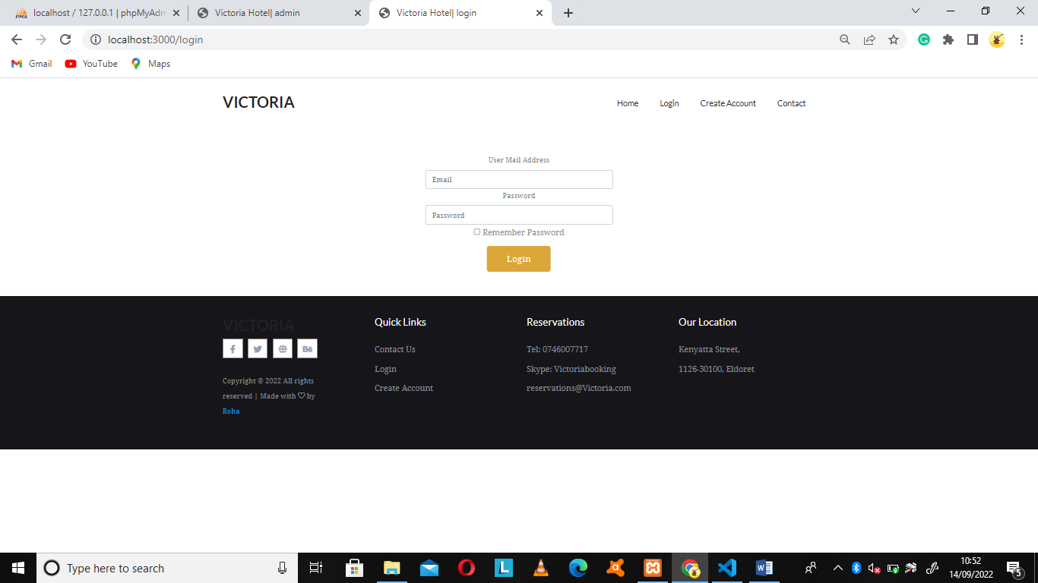

The login page also generates an error message whenever the wrong credentials are used by the client while login. The message reads “please check your information again”.

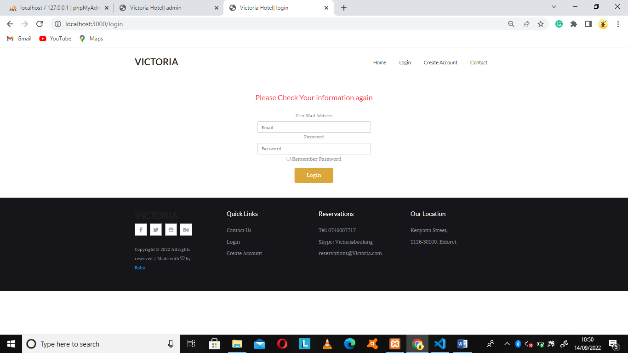

## 5.3 Home page

The home page of the hotel reservation website basically consists of four menus, that is, the home menu, Login menu, create account menu and contact menu.

The home page menu when clicked it takes the user to the home page of the website.

The login menu when clicked lets the registered user to log into the crreated account. Create account Button allow the new user to create their account. Lastly, the contact menu allow the user to be able to view contact information of the hotel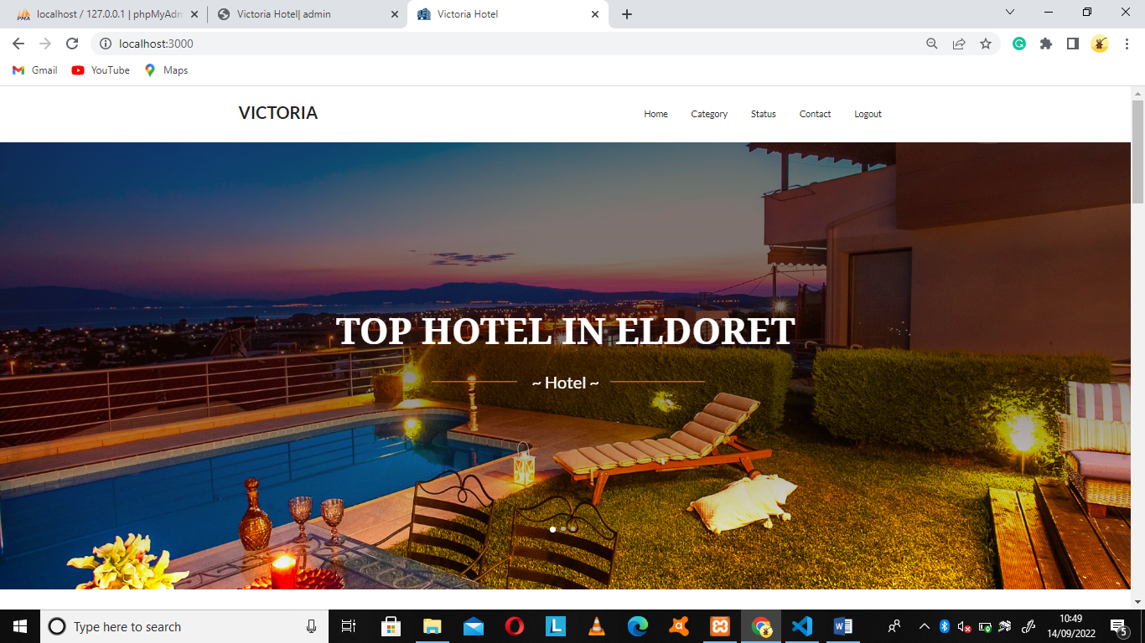

## 5.4 Create account menu

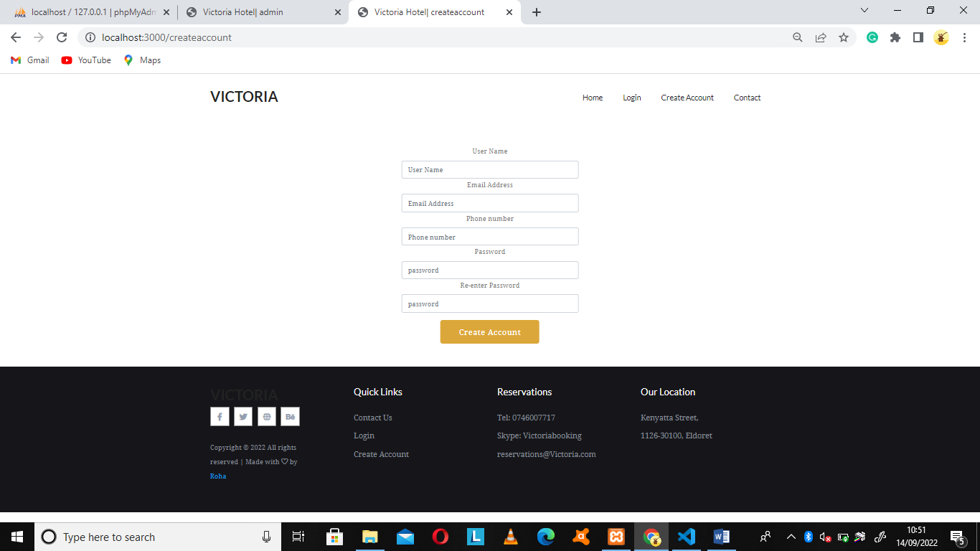

## 5.5 Admin window

The sytem administrator is also required to login to the system. The username and the password are required during login and the credentials are fetched from the database for authentication and successful login else no login will be granted. After successful login, the admin is allowed to interact with the window.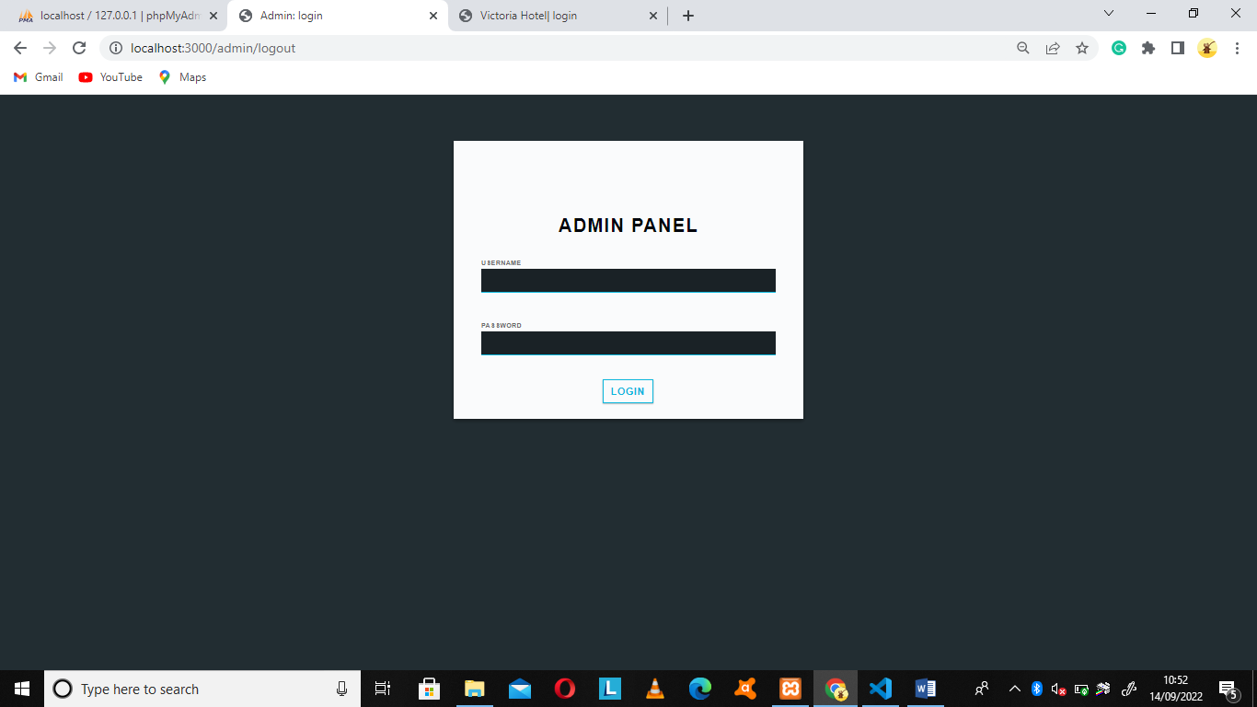

The admin is capable of approving the clients’ requests and also can cancel a clients request.

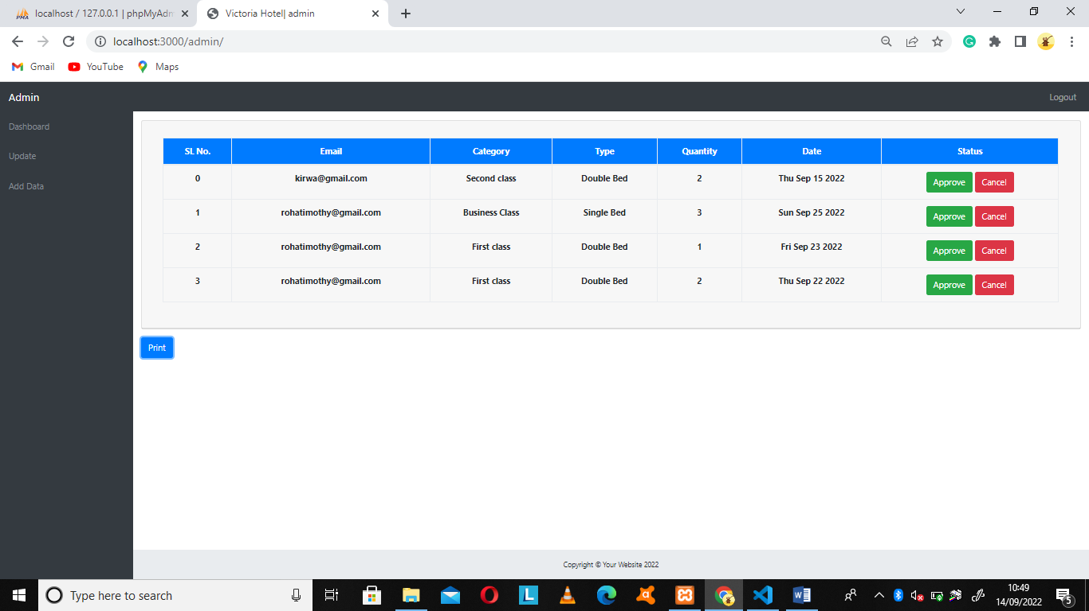

## 5.6 Administrators’ activities

The administrator controls all the activities of the hotel. The administrator accesses the system by authentication. After login the administrator can perform function such as reserve room for customer, view information stored in the database as well as granting privilege to access the system to various users and approval of clients booking. The system is flexible as more rooms can be added to it. The admin supplies room details such room name, room type, room description, room number, payable amount after which it is saved in the database. The administrator can also perform function such as data retrieval.

## 5.7 Retrieval of stored data

Another tradition in hospitality sector is to find stored data of the hotel information in the database.in this phase, we are able to get the list of customers, list of rooms available in the hotel, and list of reservation made by the customers.

# CHAPATER SIX: SUMMARY, CONCLUSION AND RECOMMENDATION.

# 6.1 Summary

Traditionally hotel management is done using pen and papers. Hotel management website is required to assist in management of data and records in the hospitality sector. The system automates the entire process of managing room reservation and monitoring resources. The new system also helps with easy reservation of rooms to the customer thereby minimizing efforts in the process.

The study revealed that several software systems exists for hotel management, some of which includes guest point, “frontdesk anywhere”, “skyware” hospitality solutions and much more. A scalable can developed and implemented to suite the environment in which it is to be used. Furthermore, it can concluded from the above discussion that a reliable, secure, fast and efficient system has been developed replacing the manual and less reliable system. The system can be implemented in hotels for better results regarding the management of customers’ data.

## 6.2 Conclusion

In conclusion I believe this project if properly utilized will save time, reduce the amount of work the administration has to do, and will replace stationery material with electronic apparatus. The system should also serve as a major tool to improving the efficiency in hotel management.

## 6.3 Limitations

1. The system has a limitation of payments method, i.e. it does not have online payment option on the online room reservation menu.
2. The customer can book a room and fail to show up since payments are done upon arrival.
3. The system is not designed to run off-line

## 6.4 Recommendation

Various benefits associated with this work and the results of the implemented system make it suitable for any hotel. Therefore, it is recommended for any hotel especially those with a large turn up of customer and where loss of customer information is common. This will protect the interest of the hotel owners and enhance good performance of the services provided. Due to the fact that there will always be an increase in the expectations and demand of customers and hotel owners and administrators will always demand great effectiveness and efficiency of any system and prevention of unauthorized access into the system. It is recommended that constant research be carried out and regular made to increase the reliability of the present system. The growth of hotel organization also depend on how well their resources ( human, assets) are managed, how well they treat their customer (hospitality) leading to large turn up, quality service rendered to customers and efficiency of system in use.

It is therefore recommended to always put this factors into consideration when implementing any policies within the organization.

### 6.4.1 Suggestion for further work

* Biometric measure such as fingerprints, retinal scan etc. should be included into the system to ensure good security of the system thereby avoiding impersonation and unauthorized access to stored data thereby preventing loss of vital information.
* Implementation of more modern online facilities that might help prospective customer interact (limitedly) more with the system and the hotel in general such as PayPal for making online transaction.
* Adequate provision should be made for customers to interact with unauthorized users of the hotel for reservation using their mobile phones.

# References

*Chen, C.F. and Rothschild, R., 2010. An application of hedonic pricing analysis to the case of hotel rooms in Taipei. Tourism Economics, 16(3), pp.685-694.*

*Ibrahim, R. (2010). Formalization of the data flow diagram rules for consistency check. arXiv preprint arXiv:1011.0278.*

*Bharadwaj, S., Vatsa, M., & Singh, R. (2014). Biometric quality: a review of fingerprint, iris, and face. EURASIP journal on Image and Video Processing, 2014(1), 1-28.*

*Fiedler, N., Bestmann, M., & Hendrich, N. (2018, June). Imagetagger: An open source online platform for collaborative image labeling. In Robot World Cup (pp. 162-169). Springer, Cham.*

*Sun, S. T., & Beznosov, K. (2012, October). The devil is in the (implementation) details: an empirical analysis of OAuth SSO systems. In Proceedings of the 2012 ACM conference on Computer and communications security (pp. 378-390).*

*Colagiorgio, P., Colnaghi, S., Versino, M., & Ramat, S. (2013). A new tool for investigating the functional testing of the VOR. Frontiers in neurology, 4, 165.*

*Li, L. J., & Fei-Fei, L. (2010). Optimol: automatic online picture collection via incremental model learning. International journal of computer vision, 88(2), 147-168.*

*Elallaoui, M., Nafil, K., & Touahni, R. (2018). Automatic transformation of user stories into UML use case diagrams using NLP techniques. Procedia computer science, 130, 42-49. Elallaoui, M., Nafil, K., & Touahni, R. (2018). Automatic transformation of user stories into UML use case diagrams using NLP techniques. Procedia computer science, 130, 42-49.*

*Anuar, J., Musa, M., & Khalid, K. (2014). Smartphone's application adoption benefits using mobile hotel reservation system (MHRS) among 3 to 5-star city hotels in Malaysia. Procedia-Social and Behavioral Sciences, 130, 552-557.*

*CHANG, H., Mei, L. I., Zhaogang, L. I. U., Yanhong, H. U., & ZHANG, F. (2010). Study on separation of rare earth elements in complex system. Journal of rare earths, 28, 116-119.*